1.随机抛硬币（10次）

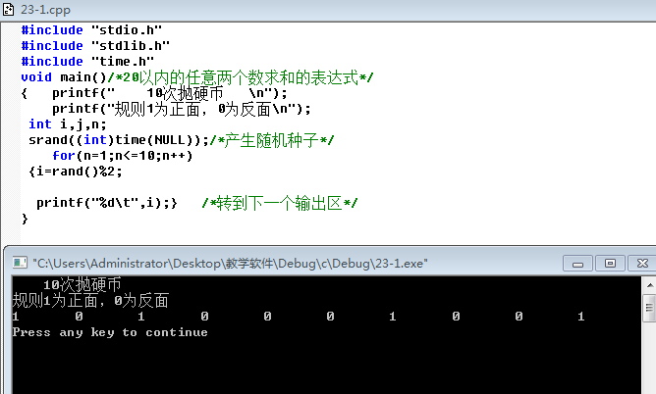

2.a+a方+a3次方+...a的n次方

[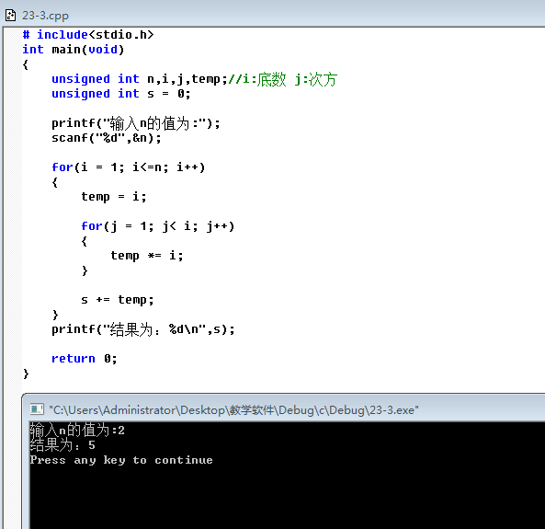](https://assets.baklib.com/t/28fa19a1-bd4e-468d-b51a-cc1195795049/u/e41e744f-8a62-49c8-9e5b-0b3866856d0c/23-31608277939401.PNG)

3.不会动的树：

[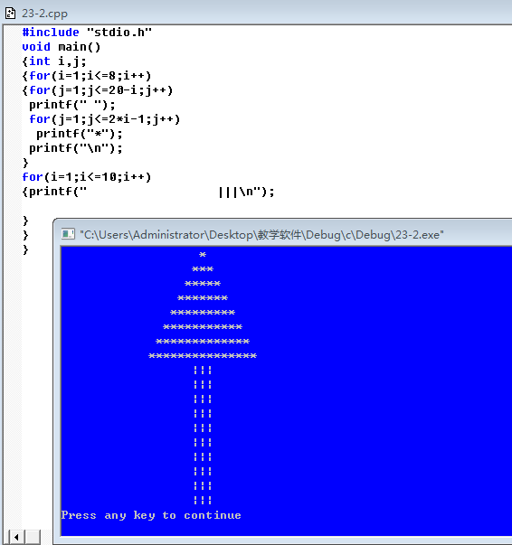](https://assets.baklib.com/t/28fa19a1-bd4e-468d-b51a-cc1195795049/u/e41e744f-8a62-49c8-9e5b-0b3866856d0c/image1608278090792.png)